Use Case 8：Shopping cart checkout

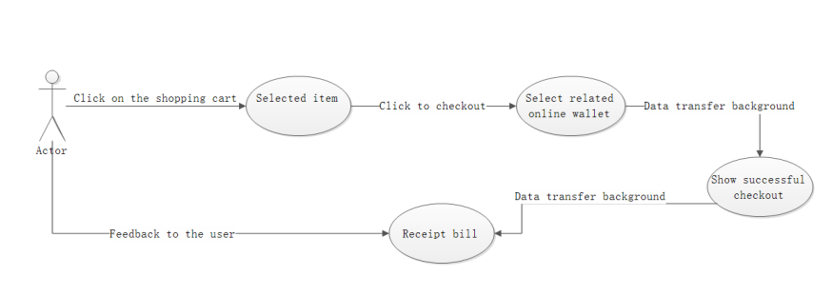

|  |  |
| --- | --- |
| User case | Shopping cart checkout |
| Related Requirem’ts | Already added the item to the shopping cart |
| Initiating Actor | user |
| Actor’s Goal | Check out the goods in the shopping cart |
| Participating Actors | System background, user, web page, internet |
| Preconditions | The relevant purchase information of the product has been completed before being added to the shopping cart. |
| Postconditions | Run related background settlement system |
| Flow of Events for Main Success Scenario | 1. Select related products to add to the shopping cart 2. Click the shopping cart button 3. Selected billing item 4. Click OK to settle 5. Use the relevant online wallet to settle 6. Successful settlement, feedback credentials |

Use Case 9：Full purchase of goods

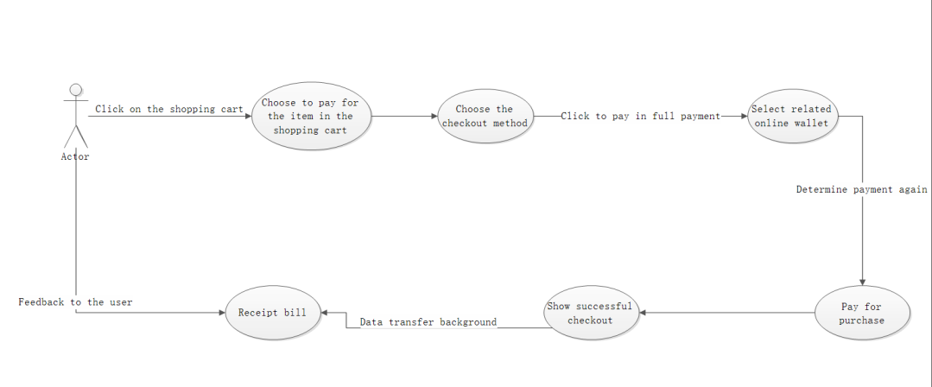

|  |  |
| --- | --- |
| User case | Full purchase of goods |
| Related Requirem’ts | Related rental products support full purchase |
| Initiating Actor | user |
| Actor’s Goal | Purchase second-hand goods for permanent use |
| Participating Actors | Website system, buyer, provider, data network |
| Preconditions | Let the lessee agree to pay the full purchase of the goods |
| Post conditions | Have enough balance in the wallet |
| Flow of Events for Main Success Scenario | 1. The user selects the payment item in the shopping cart 2. Rental projects support permanent purchases 3. Click to pay 4. Choose the full purchase, the rental time is optional 5. Confirm purchase again 6. Choose a network wallet for payment 7. Click to pay 8. Payment success feedback credentials |